**UiPath Stand Alone Orchestrator Installation On-premises - ( Single Node Deployment)**

1. **Virtual Machine**

* **VMware workstation 17 pro**

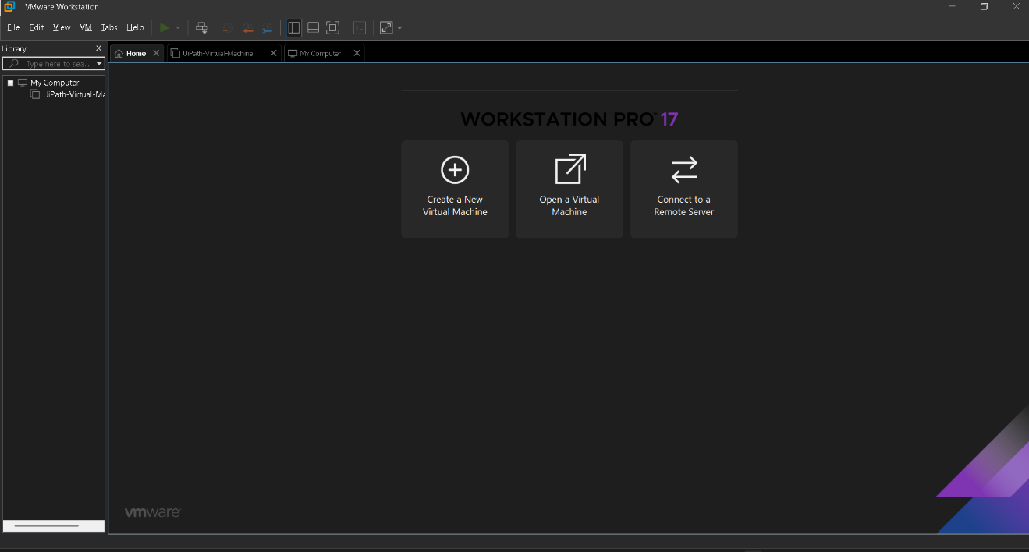

1. **Operating System**

* **Microsoft Windows Server 2022**

1. **Services (Pre Requirements)**

* **.NET SDK Framework**
* **ASP.NET Core IIS Module**
* **IIS**
* **URL Rewrite**
* **SSL Certificate**
* **Install RolesandFeatures.ps1 script**
* **UiPath Orchestrator**

1. **Database**
   * **MS SQL Server 2022**
   * **SQL Server Management Studio**
2. **Screenshots**

